6A^{th} Grade: Unit 9, Lesson 9

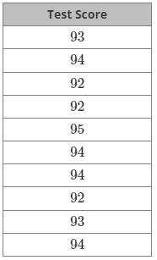
- The data from a recent test is displayed in the table. What is range of the values for the test scores?

3

- A data set is shown. What is the median of the data set?
{12, 10, 8, 5, 8, 13, 12, 7, 6}

8

- What is the five-number summary that a box plot displays?

Minimum, First Quartile, Mean, Third Quartile, and the Maximum

